**Project DevelopmentPhase Model Performance Test**

|  |  |
| --- | --- |
| Date | 21 November 2022 |
| Team ID | PNT2022TMID33370 |
| Project Name | Intelligent vehicle damage assessment & cost estimator for insurance companies. |
| Maximum Marks | 10 Marks |

**Model Performance Testing:**

Project team shall fill the following information in model performance testingtemplate.

|  |  |  |  |
| --- | --- | --- | --- |
| **S.No.** | **Parameter** | **Values** | **Screenshot** |
| 1. | Model Summary | Total params:14,789,955 Trainable params: 75,267 Non-trainable params: 14,714,688 |  |
| 2. | Accuracy | Training Accuracy – 98.66 Validation Accuracy – 73.53 |  |

**Model Summary**

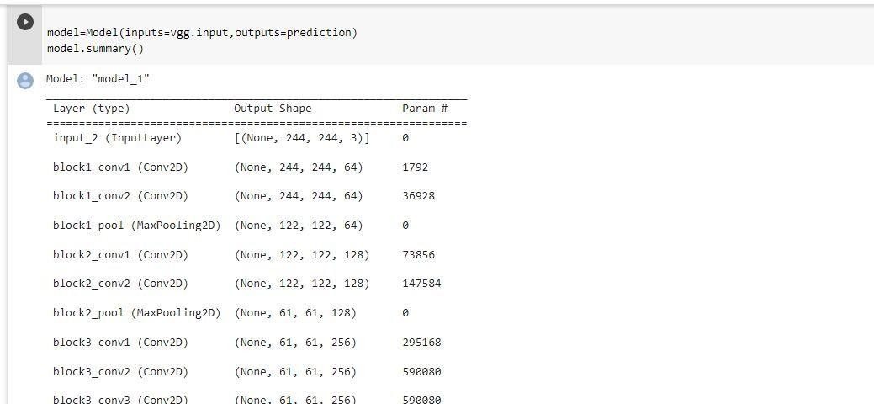

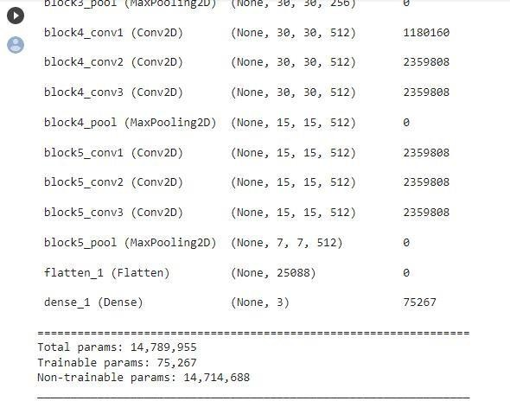

**Accuracy**

